Case 4-Eur-Croatia-Celtic Horse-Bronze-c 400 BCE

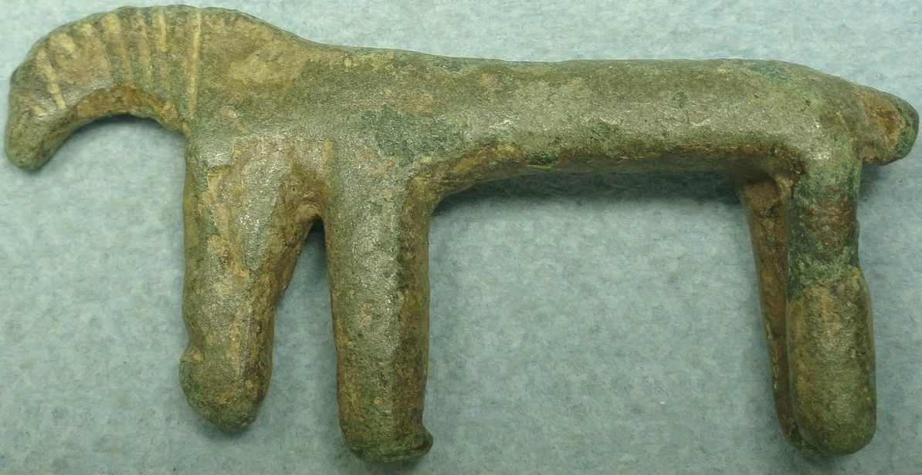

Ancient Celts, 1st - 2nd c. Bronze figure of a horse. Rider is missing. 53mm x 27mm x 10mm. Dark green patina. Found in the former Yugoslavia.

**Case no.: 4**

**Accession Number:**

**Formal Label:** Croatia-Celtic Horse-Bronze-c 400 BCE

**Display Description:**

The question that this crude amulet of a bronze horse found in Croatia raises is why is it so primitive in appearance when this is the period that the La Tène artistic florescence was beginning? In 4th century BCE Pannonia (Hungary and Croatia) mobile individuals (who are difficult to determine in ethnic terms) carried early La Tene pieces of costume in the late Hallstatt Pannonian world. Like this crude amulet of a horse we have mostly pieces of costume, not luxury items but average ones. In these lands there are no imports of luxury goods whatsoever, which is the chief insight into this amulet (see Majnaric-Pandzic, Nives. 2004).

**LC Classification:**

**Date or Time Horizon:** c 400 BCE

**Geographical Area:** Croatia

**Map:**

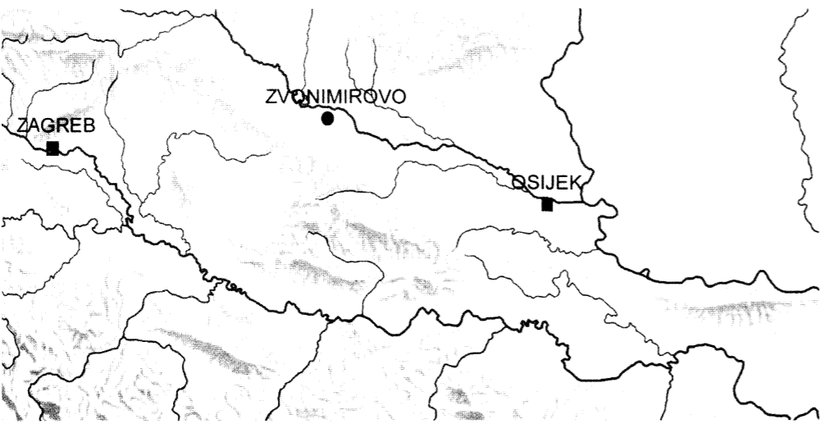

**After** Majnaric-Pandzic 2004.

GPS coordinates: Zvonimirovo, [45°49′37″N 17°33′25″E](http://tools.wmflabs.org/geohack/geohack.php?language=hr&pagename=Zvonimirovo&params=45.827_N_17.557_E_)

**Cultural Affiliation:** Celtic

**Media:** Bronze

**Dimensions:** 53mm x 27mm x 10mm.

**Weight:**

**Condition: dark green patina.**

**Provenance:** found in environs of Zvonimirov

**Discussion:**

This is the period of pre-colonizing individuals during the early Latenization in which contacts between various cultural and stylistic concepts were taking place with the confrontation of actual individuals and their individual bronze wares (see Majnaric-Pandzic, Nives. 2004).

**References:**

Majnaric-Pandzic, Nives. 2004. “Recent La Tène finds and sites in northern Croatia,” . https://iza2.zrc-sazu.si/sites/default/files/majnaric-pandzic_2009_0.pdf